1. Cyber security is the shielding of web associated systems, for example, hardware, software, and information from cyber dangers.

**Various elements of cyber security are given below:**

* Application Security
* [Information Security](https://www.geeksforgeeks.org/what-is-information-security/)
* [Network Security](https://www.geeksforgeeks.org/network-security/)
* Disaster Recovery Planning
* Operational Security
* End-user Security

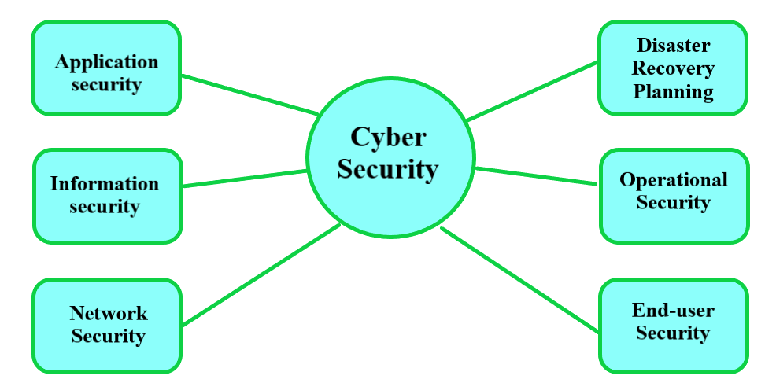

* 1. **Application Security:**Application security is the principal key component of cyber security which adds security highlights inside applications during the improvement time frame to defend against cyberattacks. It shields sites and online applications from various sorts of cyber security dangers



